Project Planning Phase
Project Planning Template (Product Backlog, Sprint Planning, Stories, Story points)

Date | 15 February 2025
Team ID
Project Name | Auto Ticket Classification using Flow Designer
Maximum Marks | 5 Marks

Product Backlog, Sprint Schedule, and Estimation (4 Marks)
Use the below template to create product backlog and sprint schedule
Sprint | Functional Requirement (Epic) | User Story Number | User Story / Task | Story Points | Priority | Team Members
Sprint-1 | Environment Setup | USN-1 | As an admin, I can set up a ServiceNow developer instance with the required roles so the team can build and test the flow. | 3 | High
Sprint-1 |  | USN-2 | As an admin, I can define the incident categories, subcategories and assignment groups (Network, Email, Software, Hardware, Service Desk) used for classification. | 3 | High
Sprint-1 |  | USN-3 | As an admin, I can prepare a keyword list that maps common words in ticket descriptions (VPN, password, printer, etc.) to a category and group. | 5 | High
Sprint-1 | Flow Design | USN-4 | As an admin, I can create a Flow Designer flow that triggers when an incident is created or updated. | 3 | High
Sprint-1 |  | USN-5 | As a flow designer, I can read the short description and description into flow variables so they can be checked. | 2 | High
Sprint-2 |  | USN-6 | As a service desk manager, I can have the flow check ticket text using If/Else keyword conditions so tickets match the correct category. | 5 | High
Sprint-2 |  | USN-7 | As a service desk agent, I can see the category and subcategory filled in automatically on every new incident using the Update Record action. | 3 | High
Sprint-2 |  | USN-8 | As a service desk manager, I can have the priority set automatically from the impact and urgency of the ticket. | 3 | Medium
Sprint-2 |  | USN-9 | As a service desk agent, I receive tickets in my team's queue because the flow sets the correct assignment group. | 3 | High
Sprint-2 | Fallback Handling | USN-10 | As a service desk manager, I can have unmatched tickets sent to a default triage group so that no ticket is left unassigned. | 2 | High
Sprint-3 | Notification and Logging | USN-11 | As an agent, I can see a work note that shows how the flow classified the ticket. | 1 | Medium
Sprint-3 |  | USN-12 | As a member of an assignment group, I receive an email notification when a ticket is assigned to my group. | 2 | Medium
Sprint-3 | Testing and Validation | USN-13 | As a tester, I can run the flow with sample incidents in Flow Designer test mode to confirm the results. | 3 | High
Sprint-3 |  | USN-14 | As a tester, I can review flow execution details and fix wrongly classified tickets by tuning the keywords. | 3 | Medium
Sprint-3 | Reporting and Deployment | USN-15 | As a service desk manager, I can view a dashboard of tickets by category, priority and SLA status. | 5 | Medium
Sprint-3 |  | USN-16 | As an admin, I can move the tested flow to production using an update set. | 2 | High

Project Tracker, Velocity & Burndown Chart: (4 Marks)
Sprint | Total Story Points | Duration | Sprint Start Date | Sprint End Date (Planned) | Story Points Completed (as on Planned End Date) | Sprint Release Date (Actual)
Sprint-1 | 16 | 6 Days | 17 Feb 2025 | 22 Feb 2025 | 16 | 22 Feb 2025
Sprint-2 | 16 | 6 Days | 24 Feb 2025 | 01 Mar 2025 | 16 | 01 Mar 2025
Sprint-3 | 16 | 6 Days | 03 Mar 2025 | 08 Mar 2025 | 16 | 08 Mar 2025

Velocity:
Each sprint lasts 6 days and the team plans 16 story points per sprint. Total story points = 16 + 16 + 16 = 48 and the number of sprints = 3, so velocity = 48 / 3 = 16 story points per sprint. The average velocity (AV) per iteration unit is sprint duration / velocity = 6 / 16 = 0.375 days per story point (about 2.7 story points per day).
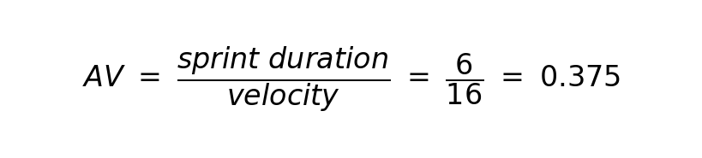

Burndown Chart:
A burn down chart is a graphical representation of work left to do versus time. It is often used in agile software development methodologies such as Scrum. However, burn down charts can be applied to any project containing measurable progress over time.
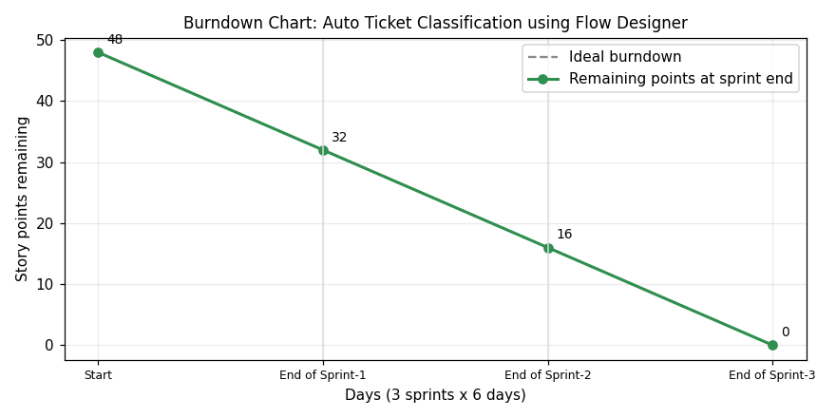

https://www.visual-paradigm.com/scrum/scrum-burndown-chart/
https://www.atlassian.com/agile/tutorials/burndown-charts

Reference:
https://www.atlassian.com/agile/project-management
https://www.atlassian.com/agile/tutorials/how-to-do-scrum-with-jira-software
https://www.atlassian.com/agile/tutorials/epics
https://www.atlassian.com/agile/tutorials/sprints
https://www.atlassian.com/agile/project-management/estimation
https://www.atlassian.com/agile/tutorials/burndown-charts

